S-100 TSM8_6.8

**Title: Roles in Feature Catalogues**

S-100 Maintenance - Change Proposal Form (Draft)

|  |  |  |  |
| --- | --- | --- | --- |
| **Organisation** | Raphael Malyankar | **Date** | 07-Feb-2021. |
| **Contact** | Raphael Malyankar | **Email** | raphaelm@portolanscie nces.com |

Change Proposal Type *(Select only one option)*

|  |  |  |
| --- | --- | --- |
| 1.Clarification | 2.Correction | 3.Extension |
| X |  |  |

Location (*Identify all change proposal locations)*

|  |  |  |  |
| --- | --- | --- | --- |
| S-100  Version No. | Part  No. | Section No. | Proposal Summary |
| 4.0.0 | 5 | 4.2.5.2 | Clarification of the use of roles in feature bindings. |
|  |  | 4.2.5.3 | Clarification of the use of roles in information bindings. |
|  |  | App 5-A | Clarify the definitions to make it clear that the roles refer to association ends and not the whole associations. |

Change Proposal

*The change proposal for clause 4.2.5.2 revises the wording and adds an examples in the form of a UML figure and corresponding extract from an XML feature catalogue.*

*The changes Table 5-A-19 revises the definitions of the literals to make it clear that they refer to association ends and not the whole association.*

**5-4.2.5.2 Feature bindings**

*[Replace the contents of clause 5-4.2.5.2 with the following.]*

The feature binding describes the association between two feature types. Each feature binding is contained within the type definition for a “source” feature type in the feature catalogue, and describes the relation of a feature type (the “target”) to the source feature type. A feature binding specifies:

• the name of the feature association;

• the target feature type;

• the role of the target feature type in relation to the source feature (the “role” is the name of

the association end at the target);

• the type of association end at the target (ordinary association, aggregation, or composition);

• the multiplicity of the target feature type.

EXAMPLE: The **TrafficSeparationScheme** feature type is associated to the **TrafficSeparationSchemeLanePart** feature by the ***TrafficSeparationSchemeAggregation*** association. This association is an aggregation and is depicted in the UML diagram below:

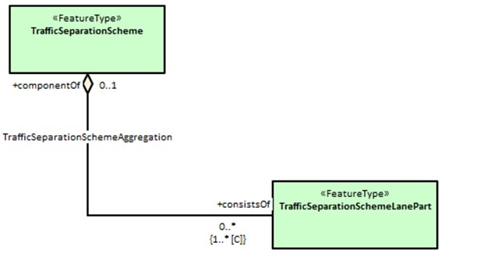

Figure X.X - UML diagram of the TrafficSeparationSchemeAggregation association between

TrafficSeparationScheme and TrafficSeparationSchemeLanePart feature classes.

In accordance with UML conventions, the diamond at the TrafficSeparationScheme end means that TrafficSeparationScheme is the “whole” or “container” in the association and TrafficSeparationSchemeLanePart is the “part” or “containee”. The feature bindings in the respective feature types in the XML feature catalogue are:

In TrafficSeparationScheme:

<S100FC:featureBinding roleType="**association**">

<S100FC:multiplicity>

<S100Base:lower>0</S100Base:lower>

<S100Base:upper xsi:nil="true" infinite="true"/>

</S100FC:multiplicity>

<S100FC:association ref="TrafficSeparationSchemeAggregation"/>

<S100FC:role ref="consistsOf"/>

<S100FC:featureType ref="TrafficSeparationSchemeLanePart"/>

</S100FC:featureBinding>

In TrafficSeparationSchemeLanePart:

<S100FC:featureBinding roleType="**aggregation**">

<S100FC:multiplicity>

<S100Base:lower>0</S100Base:lower>

<S100Base:upper xsi:nil="false" infinite="false">1</S100Base:upper>

</S100FC:multiplicity>

<S100FC:association ref="TrafficSeparationSchemeAggregation"/>

<S100FC:role ref="componentOf"/>

<S100FC:featureType ref="TrafficSeparationScheme"/>

</S100FC:featureBinding>

Note that Product Specifications or data formats may impose constraints on whether bindings are actually encoded in either of the participating feature instances in datasets.

**5-4.2.5.3 Information bindings**

*[Replace the contents of clause 5-4.2.5.3 with the following.]*

The information binding describes the association between a feature and information type or between two information types. Each information binding is contained within the type definition for a “source” feature or information type in the feature catalogue, and describes the relation of an information type (the “target”) to the source type. An information binding specifies:

• the name of the information association;

• the target information type;

• the role of the target information type in relation to the source feature or information type

(the “role” is the name of the association end at the target);

• the type of association end at the target (ordinary association, aggregation, or composition);

• the multiplicity of the target information type.

The structure of the feature catalogues is similar to the example in clause 5-4.2.5.3 except that one or both of the types will be an information type and the XML will be for “informationBinding” instead of “featureBinding”.

As for feature bindings, Product Specifications or data formats may impose constraints on whether bindings are actually encoded in either of the participating feature instances in datasets (for example, S-101 specifies that for an information association linking a feature to an information type, the binding is encoded only in the feature instance and therefore the S-101 feature catalogue may not include the binding in the information type, only in the feature type).

**Table 5-A-19:**

*[Replace this table with the following table, and add the note following.]*

|  |  |  |  |
| --- | --- | --- | --- |
| Role Name | Name | Description | Remarks |
| Enumeration | S100_FC_RoleType | Defines the type of an association end  (i.e., a “role”) |  |
| Literal | association | The association end is an ordinary linkage. (In UML terms, the role type is “aggregationKind=ordinary” and the  link in a diagram does not have a diamond.) | The object at this end may be participating in an ordinary association, an aggregation, or a composition. |
| Literal | aggregation | The association end is a UML aggregation. (In UML terms, the role type is “aggregationKind=aggregation” and the link in a diagram has an unfilled diamond at this association end.) | The object at this end is the “owner”, “whole” or “container” in an aggregation association. |
| Literal | composition | The association end is a UML aggregation. (In UML terms, the role type is “aggregationKind=composition” and the link in a diagram has a filled diamond at this association end.) | The object at this end is the “owner”, “whole” or “container” in an composition association. |

NOTE: If one end of the association is “aggregation” or “composition”, the other end must be coded as “association”.

Change Proposal Justification

Feature catalogues developed to date may not properly designate the type of an association end, for example, which of the two objects in a composition is playing the role of “containee” and which is playing the role of “container.” This proposal clarifies the treatment of roles in feature bindings so that feature catalogues properly designate the roles of the two objects partipating in a feature or information association.

What parts of the S-100 Infrastructure will this proposal affect?

☐ S-100 Feature Concept Dictionary Interface or Database

☐ S-100 Portrayal Register

☐ S-100 Feature Catalogue Builder X - may need checking

☐ S-100 Portrayal Catalogue Builder

☐ S-100 UML Models

**Please send completed forms and supporting documentation to the secretary S-100WG.**